Teaching and Learning Services / College Library
Please paste in your contributions where appropriate. Keep the text as simple and direct as possible. Add qualitative information when available, and remember that a few key anecdotes or user comments/stories are welcome.

Overview and Campus Engagement / Integration [Kelly]
Collections [Lise Snyder]
Access Services [Bob]
Instruction [Doug]
Research Skills Training and Library Instruction Sessions
Student Feedback on Library Instruction Sessions
Library instruction sessions coverage across disciplines and departments
Developing Innovative Practice and Building a New 4 year Service Model
GE Clusters [Kelly/Doug]
Writing Program engagement [Julie]
Creative Writing Program engagement [Julie]
New instructional evaluation tools
Capstones [Kelly/Doug]
Reference [Doug/Miki/Simon]
In person reference assistance
Digital Reference [Simon]
Space Improvements/Changes [Bob]
Exhibits / Programs [Cathy]
Communications
Web Team [Simon]
Social Media (Danielle)
Interns and GSRAs
Interns [Kelly/Doug/Danielle]
Social Media Interns
Space Evaluation Interns
New directions with TLS Internship program
GSRAs [Miki]
Teams and Special Projects
Social Media Learning Group [Danielle]
Eval>Value [Doug]
OPERATE-UP
First-Year Library Experience Team [Kelly/Doug]
Stressbusters [Doug/Bob/Danielle]
TLS Community Building
User Comment(s):

Draft Annual Report

2012-2013

Research Skills Training and Library Instruction Sessions
Student Feedback on Library Instruction Sessions
Library instruction sessions coverage across disciplines and departments
Developing Innovative Practice and Building a New Four-Year Service Model
GE Clusters [Kelly Miller/Doug Worsham/Danielle Salomon]
Writing Program engagement [Julia Glassman]
Creative Writing Program engagement [Julia Glassman]
New Instructional Evaluation Tools [Doug Worsham]
Capstones [Kelly Miller]
Reference [Doug Worsham/Miki Goal/Simon Lee]
In-person Reference Assistance
Digital Reference [Simon Lee]
Space Improvements/Changes [Bob Freel]
Exhibits / Programs [Cathy Brown]
Communications
Web Team [Simon Lee]
Social Media [Danielle Salomon]
Interns and Graduate Student Reference Assistants (GSRAs)
Interns [Kelly Miller / Doug Worsham / Danielle Salomon]
GSRAs [Miki Goral]
Teams and Special Projects
Social Media Learning Group [Danielle Salomon]
Eval>Value [Doug Worsham]
OPERATE-UP [Doug Worsham]
First-Year Library Experience Team [Kelly Miller/Doug Worsham]
Stressbusters [Doug Worsham/Bob Freel/Danielle Salomon]
TLS Community Building [Doug Worsham / Margarita Nafpaktitis]
User Comment(s):

Overview and Campus Engagement / Integration [Kelly]

In 2013-2014, Teaching and Learning Services, which provides leadership on reference and instructional activities at the UCLA Library, continues to evolve and grow. As a member of the Executive Vice Chancellor’s new standing committee on Online Education, Kelly Miller is helping lead the UCLA Library’s engagement with campus conversation on online, hybrid, and blended learning. Kelly has significantly increased the Library's engagement with the Division of Undergraduate Education, forming collaborative relationships with the Office of the Dean of Undergraduate Education and the Undergraduate Research Centers on North and South Campus, developed the Library's interaction with the Office of Residential Life and First Year Experience Program, and facilitated a new partnership with Writing Programs in support of peer-to-peer learning. Kelly also worked closely with the Director of the Freshman Cluster Program to expand library engagement with the high-impact curricular program for undergraduate students; for the first time ever, librarians taught Spring Quarter seminars, participating fully in the Cluster Instructional Teams alongside faculty and TAs. Moreover, due to outreach to faculty and administrators in the Digital Humanities Program and Center for Digital Humanities, College librarians taught new library workshops as part of DH 194: DH Research Group Seminar, a required course in the DH undergraduate minor. In terms of outreach to student communities, Kelly facilitated new Library engagement with campus student associations and communities, including the Undergraduate Students Association Council (USAC), the UCLA chapter of School on Wheels, and the Enigma: Science Fiction, Fantasy, and Gaming student group, among others.

Highlights of outcomes of campus engagement in 2012-2013 include:

- TLS involvement in campus-wide conversations on the future of Online Education at UCLA

TLS is representing the UCLA Library on a new standing committee on Online Education at UCLA, led by Executive Vice Chancellor Scott Waugh. This committee’s work framed the first "Teaching and Learning in a Digital Age," UCLA's first-ever summit on online education led by faculty member, Jan Reiff.

- New alignment of library services with the undergraduate curriculum

Conversations with the outgoing Dean of Undergraduate Education, Judi Smith, new Dean of Undergraduate Education, Pat Turner, and the Dean’s Accreditation Coordinator, Jennifer Lindholm, have led to ability to reframe the Library’s services in alignment with goals for UCLA undergraduate education. As a result of these conversations, Kelly was invited to present with the Deans on a panel entitled “Capstones, Core Competencies, and Conundrums: Student Experiences and Lessons Learned” at the WASC 2013 Academic Resource Conference in San Diego (April 11, 2013). Such engagement raises the visibility of the Library’s support for undergraduate education. TLS is now working with the Dean’s office to identify three departments to pilot the collection of capstone projects in e-Scholarship. The Dean’s office has also worked with Kelly to draft a new framework for library engagement with the undergraduate curriculum that is being called the “Inquiry Program.”

- Increased integration of librarians into the Freshman Cluster Program’s instructional teams with strategic involvement of subject librarians from across the UCLA Library. For the first time ever, each Cluster course had two or more librarians assigned to provide support. These librarians experimented in new and fruitful ways with strategies for faculty and student engagement.

- Brought peer-to-peer learning into the Library. Developed a pilot partnership with the Undergraduate Writing Center, bringing undergraduate Peer Learning Facilitators into the library to offer their services for the first time ever. These PLFs were cross-trained by librarian, Julia Glassman, on providing basic library assistance. In one quarter alone, the students provided consultations for more than 300 students.

- Library membership on the new Academic Development Committee in the Office of Residential Life

Academic Development Committee (2012-) -- Mission Statement
The Office of Residential Life Academic Development Committee supports the academic and intellectual advancement of students by fostering partnerships with campus academic partners, cultivating relationships with faculty, and developing services, resources, and support systems that strive to facilitate active learning and engagement.

- Library participation in the inaugural First Year Experience Freshman 15 workshop series

Freshman 15
The Freshman 15 series, in collaboration with campus partners, provides first year students access to traditional and skills-based workshops that cover topics important to transitioning students including: student success/campus navigation, academic resources, research skills, health and wellness, service and social responsibility, financial literacy, and diversity/multicultural awareness. Instead of the negative association with the phrase “Freshman 15”, we want students to understand that this series can have positive impacts on their student experience at UCLA.
- Library participation in ORL’s Academic Success Workshop for more than 400 student Resident Advisers in September 2012.

- Co-taught two undergraduate courses with Special Collections colleagues, increasing undergraduate engagement with cultural heritage materials: HNRS 101I: Research Today: Sources, Tools, and Strategies (w/Heather Briston), and GE 66 Spring Seminar: Mapping Literary LA (w/Rob Montoya)

- Facilitated successful English Department application for the Affordable Course Materials Initiative. That project is now getting underway under the direction of AUL Sharon Farb and Clark Librarian, Shannon Supple, with assistance from Julie Glassman and others.

Hired in September 2012, Doug Worsham is coordinating a number of new enterprise-wide groups focusing on library support for undergraduates, including UCLA's First Year Experience program, the Freshman Cluster program, and the Capstone Initiative. Doug has also formed a new team called "Evaluation > Value" to better collect and communicate statistics and findings on the impact of library reference and instructional activities for all users, including both undergraduate and graduate students. Simon Lee is chairing the TLS Digital Reference Steering Committee, providing leadership in online reference services for the UCLA Library community, and Danielle Salomon is leading a Social Media Learning Group that is providing guidance on social media use in teaching and learning enterprise-wide.
In the coming year, new and evolving emphases will include collaborative collection management in support of undergraduate education, ensuring the success of the Affordable Course Materials Initiative, and strategically increasing librarians' engagement at the curricular level in three areas: Freshman Cluster Program, Writing Programs, and Undergraduate Research and Capstones.

Collections [Lise Snyder]

Core Collection [Lise Snyder]
  - Core collection development/selection responsibilities were redistributed to involve all College librarians. Each librarian selected subject areas of interest/expertise, were oriented to Core collection development practices and use of YBP GOBI for selecting and ordering titles and given an allocation for their areas. All selectors will participate in the extensive Core collection weeding project slated for the 2013 -14 academic year and the development of faculty and student engagement in future Core collection building.
  - A plan to reduce the Core collection is being developed for implementation in 2013-14. This will free up space for increased student seating.
  - A proposal was prepared and accepted to develop a limited PDA ebook project using ebrary titles. Lise Snyder will work with Roxanne Peck to implement this project in 2013-14. The project will be assessed for possible future expansion.
  - A plan was developed to expand seating capacity in the Main Reading Room (MRR) by withdrawing most bound periodicals and moving print reference materials off the the free-standing cases to MRR wall shelving. Plan is currently being executed and should be completed by fall 2013.
  - The popular magazine collection was moved from the East Rotunda to the Main Reading Room to increase its visibility and free up space in the East Rotunda for the newly developed Zine and Cookbook collections (see Thematic Collections below.)

Reference Collection [Cathy Brown]
  - Conducted an assessment of the reference desk collection and ordered new editions of important titles. Work will begin during summer 2013 to shift all print reference materials off free-standing cases to the reference wall collection.
  - Stephen Sherwin moved most of the literary criticism books in the Z call numbers to the reference wall collection, removed single volumes from the biography case, and began work on moving a large literary criticism set to the stacks.
  - Cathy Brown set up a trial for AccessScience, the online version of the McGraw Hill Encyclopedia of Science and Technology. While faculty and TA feedback was lukewarm, the Science and Engineering Library volunteered to contribute one third of the cost to test the product for a year as an alternative to Wikipedia for students in sciences and engineering. A substantially discounted price and license agreement were negotiated with McGraw Hill. Diane Gurman in Scholarly Communication and Licensing negotiated the license, which will allow UCLA to subscribe to other McGraw Hill electronic products in the future.

Thematic Collections [Lise Snyder, Julia Glassman, Danielle Salomon, Simon Lee]
    - Zines. [Julia Glassman] Approximately 60 zines have been purchased for our initial collection. Relationships were formed with local zine authors, including UCLA students and alumni, at events like the LA Zine Fest and the Claremont Zine Fest. A Student Zine Committee has been formed, consisting in part of students from the UCLA-based Bad Art Zine Collective and the UCLA Student Committee for the Arts, and plans are underway for a Fall Quarter launch event. Students have already begun to use the collection for their coursework by making appointments to work with our archival copies.
    - Recent Fiction. [Julia Glassman] Several changes were made to the Recent Fiction Collection this year. Student feedback has been gathered through informal interviews with Powell student workers and a “What Do You Want to Read?” board in the Main Reading Room. A rotating thematic display has been set up in one corner of the Rose Gilbert Reading Room, featuring themes including young adult fiction, new arrivals, award winners, spring break reads, and Scandinavian fiction. Young adult titles have been especially popular with library users, enjoying a check-out rate over 50% higher, on average, than other items in the collection’s rotating display. Finally, a Student/Staff Picks program has been instituted, in which recommendations from students and staff members are displayed alongside items.

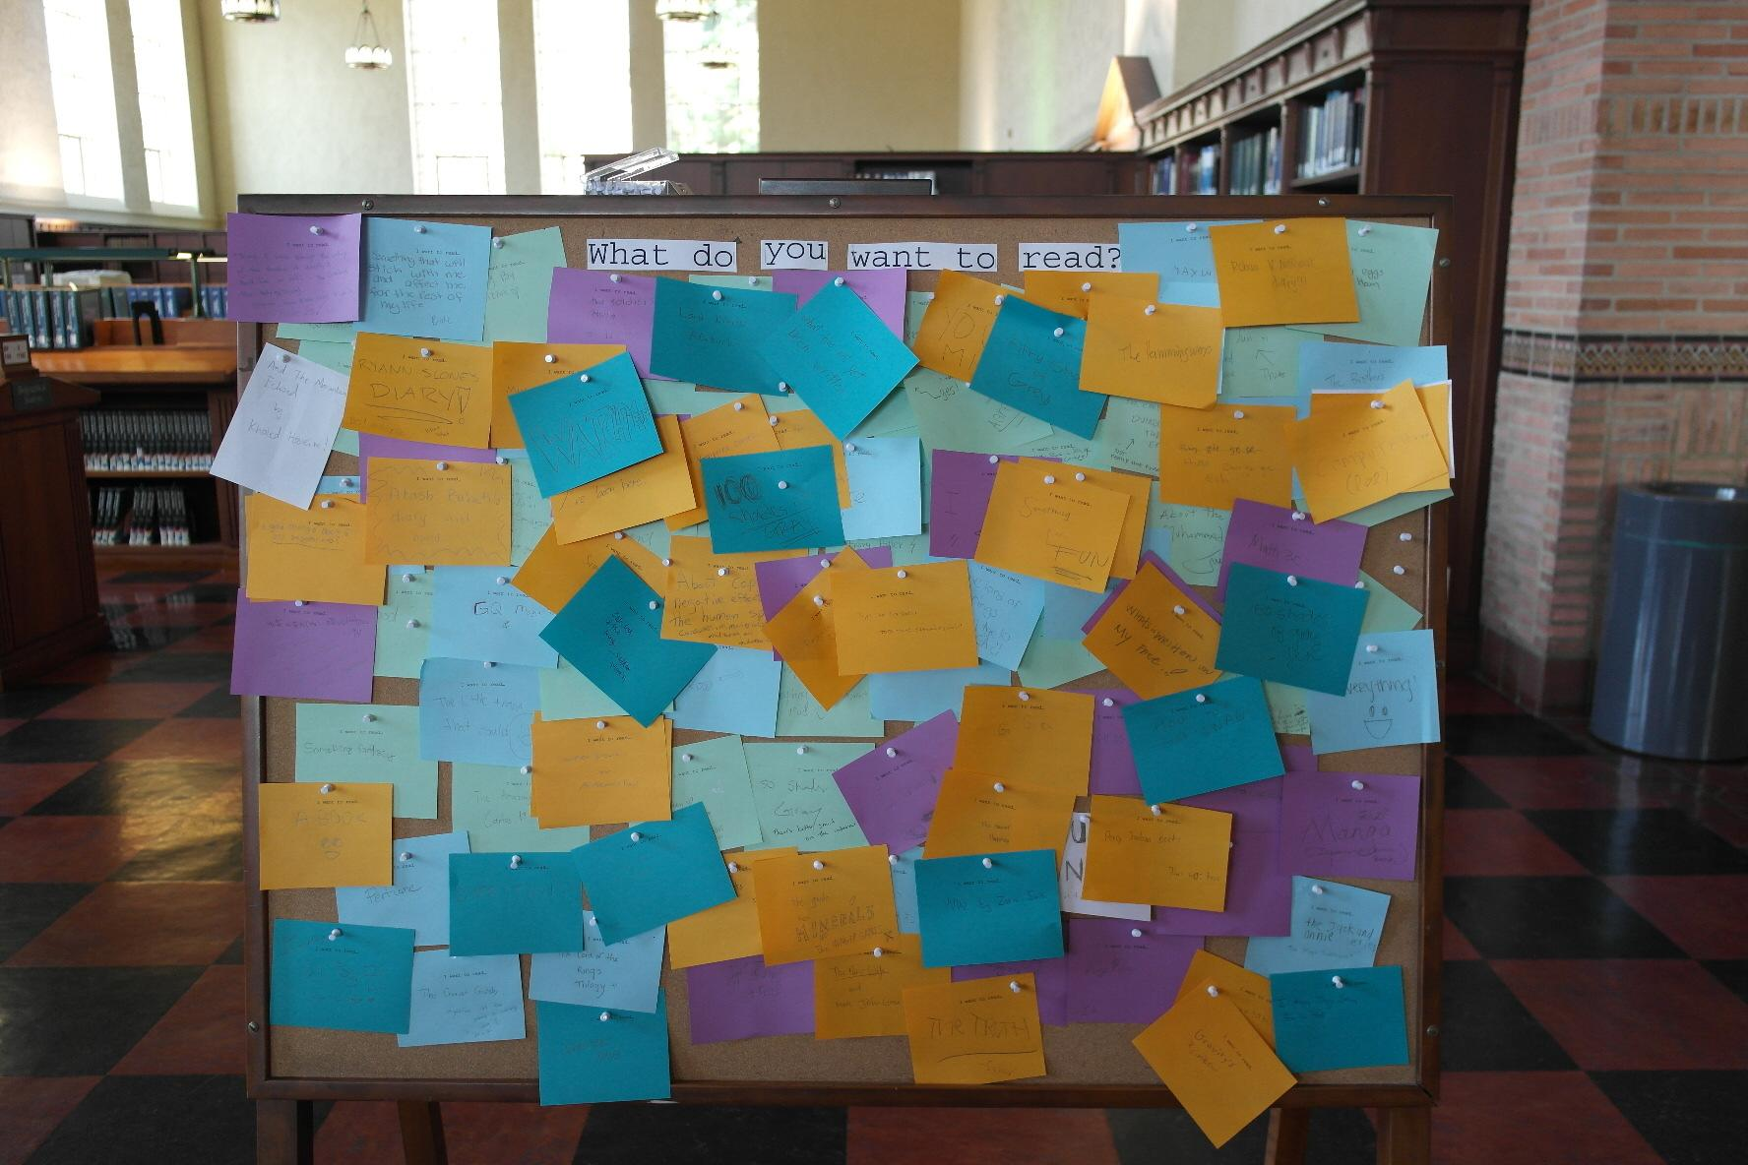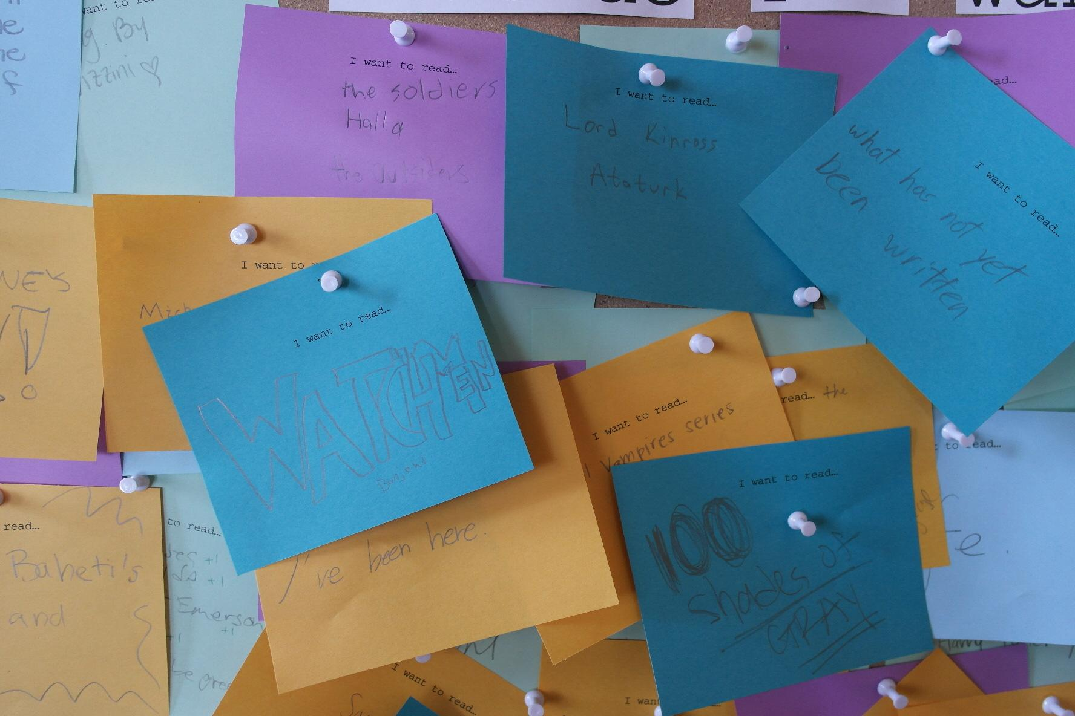
“What do you want to read?” board

    - Cookbook Collection. [Danielle Salomon] Danielle Salomon developed a proposal for a student-curated cookbook collection that was accepted and implemented. Cookbooks were selected by members of the Bruin Culinary Community, a registered student group, working with Danielle. Books were selected, purchased, and made available for checkout at the Edible Books Festival held in College/Powell Library on April 5, 2013. Cookbooks in the current Core collection were reviewed and some selected and moved to the East Rotunda location.
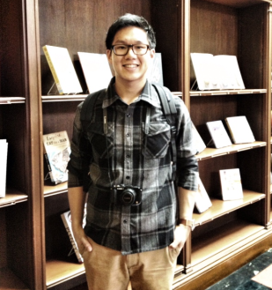
Joshua Lu, President of the Bruin Culinary Community, in front of the Community Cookbook Collection

    - Graphic Literature Collection. [Lise Snyder] The Graphic Literature Collection, both fiction and non-fiction, continued to grow supported by Rose Gilbert funds. This academic year, emphasis was placed on selecting works by diverse authors. [more detail on what is meant by diverse authors?]
    - Enigma Collection. [Simon Lee] “Enigma: The Science Fiction, Fantasy, and Gaming” student group offered to donate their library collection to the College/Powell Library. Their proposal to donate this gift of 1000+ items was approved and the collection is now being reviewed for duplication in the other libraries. Tina Metalis, an undergraduate student officer (librarian) of Enigma, initiated an independent study with the library to work on this project in the spring.

For the first time, College/Powell participated in the Library’s annual spring Champagne Reception in honor of Library donors that features recent acquisitions. Our reception table featured our thematic collections including zines, cookbooks, and Enigma titles. On hand to discuss these collection with donors were Kelly Miller, Julie Glassman, Simon Lee and Tina Metalis (3rd-year student and current Enigma Librarian), and Danielle Salomon.

Access Services [Bob]

Highlights of outcomes of Access Services in 2012-2013 include:

- Plans for a new service model began in March 2013 when a team was appointed. The team, chaired by Bob Freel, includes Miki Goral, Stephen Sherwin, Allison Benedetti (YRL CRIS), and Gaby Mittelbach (CLICC). The new service model wil feature an integrated service point that will serve all user needs. The new desk will be staffed with students and Library Assistants, and Librarians will be available by appointment in a space better suited for consultation. The task force has created a project plan, read literature, made a site visit, and held a workshop for College Library staff.

- College Library provided 24/7 service during tenth week and finals for winter and spring quarters. It’s anticipated that 24/7 service during tenth week and finals will continue permanently.

- Student Worker Experience: Access Services staff are currently planning a new structure and training model for student staff, Michael Elliott is the College Library representative serving on an enterprise wide student training group.

- Selected Statistics
 | FY 11/12 | FY 12/13 | Difference | % Change
Gate Count | 1,224,572 | 1,317,568 | 92,996 | 7.6%
Hours Open | 3,693 | 3,858 | 165 | 4.5%
Total Charge Outs | 131,848 | 126,012 | -5,836 | -4.4%
Reserve Charge Outs | 88,232 | 84,696 | -3,536 | -4.0%
Non-Reserve Charge Outs | 43,616 | 41,316 | -2,300 | -5.3%
Discharges | 135,237 | 128,753 | -6,484 | -4.8%

Reserves

- Assessment of reserve operations is underway. Although there was a 4% decrease in reserve charges outs this year over last, reserve charges have increased by 26% over the past three years. This is an opportune time to assess reserver services and improve internal processes. Preliminary data from student users suggests that longer loan periods are desired. Faculty users have been identified for further consultation.

- Reserve Statistics
Circulation Transactions | FY 11/12 | FY 12/13 | Difference | % Change
Total Class Lists | 1,098 | 1,244 | 146 | 13%
UCLA Owned Items | 9,770 | 9,221 | -549 | -6%
CROTF\Personal Copies | 455 | 745 | 290 | 64%
Links Added | 54 | 89 | 35 | 65%
Articles Scanned | 218 | 0 | -218 | -100%

Student Staff
- Student staffing was increased from 32 to 40 during mid 2012/13.

- Access Services Students provided support for social media and outreach assistance.

Instruction [Doug]
While continuing to deliver instructional support through library instruction sessions, the College Library “Teaching and Learning Team” (College TLT) is actively exploring innovative practice, fostering new relationships with faculty and instructional staff, and creating new possibilities for engagement with undergraduate students.

Research Skills Training and Library Instruction Sessions
The College TLT facilitated over 200 library instruction sessions and workshops for more than 4600 learners during the 2012-2013 academic year.

Student Feedback on Library Instruction Sessions
Students attending instruction sessions led by College staff have overwhelmingly positive responses:
- 94% report feeling more confident as researchers as a result of the session
- 91% describe their College Library instructors as “very motivated” or “exceptionally motivated” to help them learn.
- 78% report that they are more likely to contact library staff for help as a result of the session.
- Quotes from student feedback on library instruction sessions
  - Alicia is really helpful, I learn a lot about our library.
  - Cathy was very helpful and skilled at what she does.
  - Danielle was extremely upbeat, clear, and concise.
  - Doug did a wonderful job facilitating today's session. He also was very approachable and full of enthusiasm!
  - Julie's instruction was very insightful. I will certainly use her as a resource in the future.
  - Kelly rocks!
  - Lise helped develop my research skills, introduced new online resources I could use, as well as helped us in planning our research topic.
  - Miki made the lesson very interesting and expanded my knowledge of the library's resources.
  - Simon helped me to answer my questions really well!

Library instruction sessions coverage across disciplines and departments

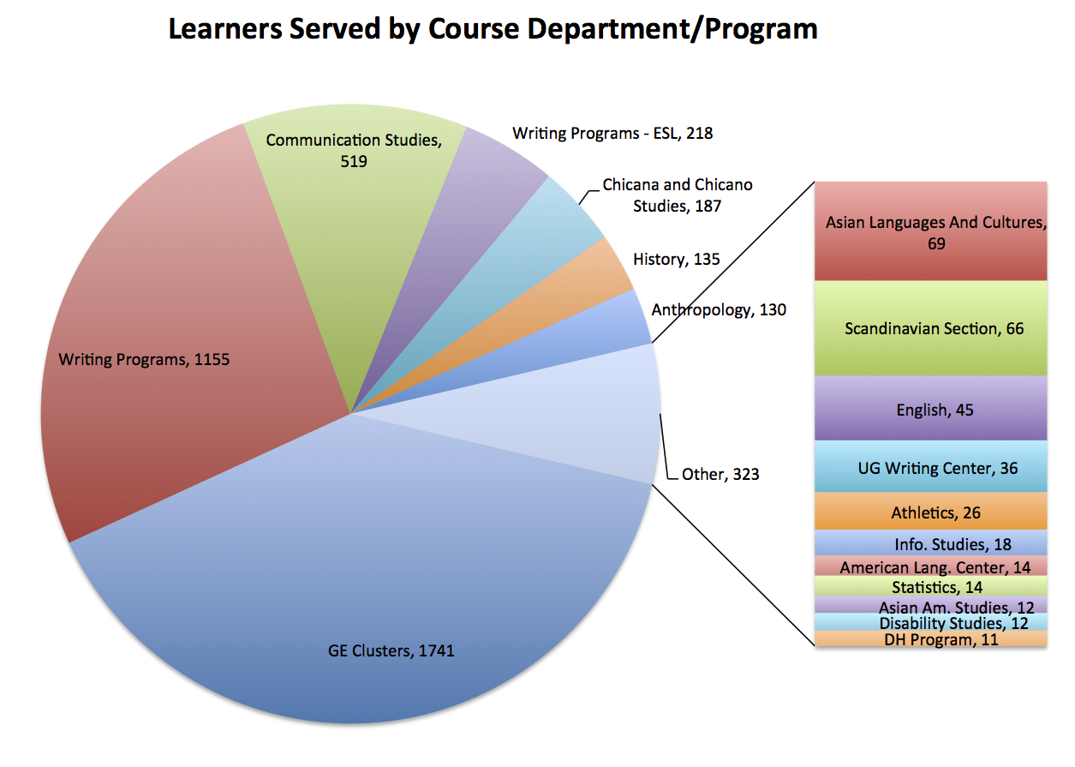

Developing Innovative Practice and Building a New 4 year Service Model

GE Clusters [Kelly/Doug]
“I think that having a designated librarian for the cluster is a fantastic gift our cluster is giving our students. Private schools pride themselves in assigning librarians to students, and we are able to do it here at UCLA through the cluster. It's truly a gift.” - Quote from the GE Cluster Instructor Survey, Spring 2013

This year the College TLT partnered with staff across UCLA Library to explore a variety of ways to collaborate with instructors and engage with students in the GE Cluster program.

Library staff explored a variety of new “embedded” approaches including attending and participating in lectures and discussion sessions, meeting with students one-on-one to assist with research and writing projects, actively participating in planning meetings with faculty and graduate teaching assistants, developing and teaching spring seminar courses, and more.

UCLA Library staff taught 3 UCLA credit courses, 2 of which were directly related to GE Cluster courses:
Wired Minds: What the Internet Is (or Isn’t) Doing to Our Brains (GE CLST 73CW HIST&SCI&PHIL-BRAIN)
Instructor: Danielle Salomon

On course evaluations, students rated the improvement of their library and research skills “much stronger” as a result of the seminar (library skills: 3.64 of 4; research skills: 3.67 of 4)

Comments:
“I enjoyed learning about different research techniques. I will definitely use them throughout the rest of my college experience.”
“Helped to increase knowledge of Internet..., helped with writing and research skills.”

Los Angeles: The Cluster -- Special Topics: Mapping Literary Los Angeles (GE CLST 66CW LA-THE CLUSTER , SEM 9)
Instructors: Kelly Miller (College Library/TLS) and Robert Montoya (Special Collections)

Research Today: Sources, Tools, and Strategies (HNRS 101I - Research Today)
Instructors: Kelly Miller (College/TLS) Heather Briston (Special Collections)

Writing Program engagement [Julie]
- This year, we piloted a new program in which student Peer Learning Facilitators (PLFs) from the Undergraduate Writing Center are trained in research assistance and serve students in a new location here at Powell. Upon learning that PLFs in all three Writing Center locations were benefiting from the initial training, we expanded the training regimen to PLFs at other locations.
- Julie Glassman and Doug Worsham are currently working with Bruce Beiderwell and other Writing Programs stakeholders to create online modules for basic library instruction (e.g., finding and searching the catalog). Our tentative plan is to use these modules to create a blended online/in person approach to instruction sessions, in which Writing Programs students practice basic library skills at home, and then receive in-depth help on specific assignments from instruction librarians. Pending input from staff and students, our goal is to have a prototype ready to pilot by Fall Quarter.

Creative Writing Program engagement [Julie]
- Engagement with UCLA creative writing students has included both instruction to creative writing courses and events coordinated by Westwind, UCLA’s Journal of the Arts, and the Writer’s Den, UCLA’s student creative writing organization. Instruction has included “research for writers” sessions for a poetry workshop and a creative writing honors seminar. Further instruction sessions and workshops are planned in conjunction with UCLA’s creative writing summer institute. Events have included Westwind student readings; student-led author readings with Mary Ruefle, Lisa Stasse, and other writers; and a “Book Sprint,” a competitive event in which Writer’s Den and Westwind students wrote book reviews for Powell’s Student Picks program.


Two students at our first Book Sprint.

New instructional evaluation tools
The College TLT seeks to improve instructional efforts across UCLA Library by providing tools and infrastructure for instructors to evaluate and reflect on their teaching practice. 3 new evaluation tools were developed:
- new instruction session student survey (winter, spring)
- new instruction session instructor survey (spring)
- GE Cluster instructor survey (spring) “Investigate possibility for assessing student learning as result of library involvement in GE Clusters”
  - raw data has been received from Fall 2011-on. Analysis forthcoming.

Capstones [Kelly/Doug]

Reference [Doug/Miki/Simon]

In person reference assistance

9144 questions were answered at the College Library reference desk:
- Directional - 2822
- Inquiry - 5185
- Research Assistance - 1098 (435 > 10 minutes)
- Research Consultation - 39

There were an additional 1147 questions answered by email.

Digital Reference [Simon]

Digital Reference continues to be a strong service for library users. The gratitude is expressed directly from survey responses coming from our UCLA students and other library users:

“I love live chat! it's the best. I don't have to change what I'm doing, I just sit at my computer and ask a few questions, test stuff out and I'm off and running.” - UC student

“I found out about this service on a blind websearch and it's terrific! Please, keep it going because it's a great service to your clientele.” - May 10, 2013

“service was over & above my needs. thank you!” - UCLA staff

“She [24-7 Academic Cooperative] was really really helpful, a lot more helpful than I expected! I got the help I needed plus some search terms suggestions that will be helpful for my research. This is a great service. It was my first time using it and I was surprised that someone was available on Memorial Day, let alone using so much time to help me.” - May 27, 2013

“Thank you so much Julie [Glassman], you really helped me out.” - UCLA student

“Wonderful, prompt, knowledgable.” - May 28, 2013

In addition to student commentary, the Digital Reference Steering Committee contributed to its success through the following:

Promotion. Enhance community awareness of digital reference “Ask a Librarian” services by promotion and publicity. The DRSC regularly promoted digital reference services through online and social media venues by scheduling monthly posts in the College, Biomedical, Science & Engineering, and Research libraries. A major accomplishment was the implementation of the “Ask a Librarian” qwidget to library licensed resources such as EBSCO and ProQuest databases to meet users at the point-of-need.

Expansion. Recruit digital reference staff and ensure stable, quality research assistance to users on the “Ask a Librarian” service. There are currently 27 digital reference staff members compared to 8 in fall 2011. In the winter/spring of 2011, we trained the following:

Training Completed in Winter/Spring 2012
Elizabeth Cheney
Adele Dobry
David Hirsch
Alicia Reiley
Danielle Salomon
Lise Snyder

Since Fall 2012, the DRSC completed training for 11 new members:

Training Completed in Fall 2012
Allison Benedetti
Marta Brunner
Diane Mizrachi
Margarita Nafpaktitis
Jennifer Osorio

Training Completed in Winter 2013
Catherine Brown
Julie Glassman
Robert Gore
Janine Henri
William Huggins
Diana King

Vision and Future. Create vision and plan for moving digital reference into positions as a core function of UCLA Library’s service portfolio, ensuring long-term success of remote reference service.

In early fall, communication of current issues and resource needs of the service was provided to the incoming Teaching and Learning Services Coordinator, Douglas Worsham. As of winter/spring, new members of the DRSC (Liz Cheney and Allison Benedetti) will aid in the maintenance and continuation of the services. To free up time from the DRSC members, a pilot project will be proposed by Allison Benedetti on Friday, June 21st.

Space Improvements/Changes [Bob]

Space changes and improvements in 2012-2013 include:

- Room 236A: A peer to peer consultation space known as the “InqDrop” was conceptualized, designed, and installed at the end of June. This intimate space, formerly a microfilm room, can accommodate up to nine students, features two collaborative pods (42” video screens that easily connect to laptop computers) and mobile furniture. The room will officially go on line before fall quarter.

- Room 220: A design to transform the College Library staff space into Inquiry Lab was completed and furniture ordered for installation in Summer 2013. Known as the “InqSpace”, this open and bright 3,760 SQF room, will provide a dedicated space for students to consult with librarians and student consultants known as “Inquiry Specialists”. The space will feature informal meeting and presentation areas, a maker space where exhibits, signs, and displays are assembled. The “InqSpace” will transform how College Library staff and librarians work and serve the public in new and exciting ways.

- Rooms 228 & 238: Planning is underway to transform two traditional classrooms into technology enabled Inquiry Learning spaces. These new spaces will be known as InqLab 1 & 2.

- Discussion has begun on increasing by 40% user seating for study and learning by repurposing stacks.

- Furniture
  - A major cleaning and/or re-upholstery of all soft furniture (sofas, chairs, and benches) happened at the end of the school year in June.
  - All of the signature Stickley furniture was oiled and reconditioned.
  - Twenty bean bag chairs were well received by our undergraduates.

- All of the Michael Elliott provided service and support for reconfiguring public spaces and classrooms throughout the year. The Staff Conference Room provided double duty for meeting space and was also reconfigured for the UCLA Writing Center Peer Learning program.

Exhibits / Programs [Cathy]

Exhibits:

A new hanging system was purchased and installed in the first floor Night Powell study space which consisted of ten track rails on the west side of the room and a secure cable hanging system from AS Hanging Systems. Two poster displays were installed during this first year:

- Fall and Winter quarter: Six posters created by students who participated in the Helen S. and Alexander W. Astin Civic Engagement Scholars program. Douglas Barrera, Assistant Director of the UCLA Center for Community Learning, coordinated loaning the posters to College Library.

- Spring quarter and Summer sessions: Einstein’s Dreams, an exhibit designed and curated by Design|Media Arts department chair, Willem Henri Lucas, featured the best work created by students in his Winter 2013 DESMA 25: Typography class. Janine Henri from the Arts Library facilitated the initial contact with Professor Lucas.

Rotunda exhibits:

- Public Science: Peep Shows, Caskets and Microscopes
June - September 2012
Curated by students from GE 21CW, History of Modern Thought, with coordination from seminar instructor Marissa Petrou, and librarians Russell Johnson and Genie Gerard from Library Special Collections. Portions of this exhibit were also featured in the Charles E. Young Special Collections and Biomedical Library History and Special Collections for the Sciences. It featured ephemera which spanned the 17th to the 20th centuries and documented how people learned about scientific advancements through three-dimensional objects.
Exhibit comments:
“Such a great exhibition, clear and easy to follow. The students did a great job. Bringing objects out of the library’s special collection vaults was a great idea; seeing the objects with our own eyes solidifies our knowledge and ability to understand the world around us.”
“I like the signage for the display. To have the scope of the exhibit repeated in each case is very good. I also like the variety of materials from instruments, anatomical models, documents to stamps and photos.” A visiting librarian from San Diego
“Best exhibit at Powell yet!!”
“Excellent work on the peepshow and microscope exhibit!I especially like the 3-d shows of the Thames and ballrooms on the lower level. Thank you for the intriguing setup UCLA!! You gave me a topic for my research paper.”

- California Political Celebrities: Voting in the Golden State
October - December 2012
Curated by Catherine Brown, with assistance from Maria Jankowska, Gabriella Gray, and Scott Martin from YRL CRIS. Told the story of famous California governors and presidents along with voting demographics and information for student voters. The exhibit featured books and ephemera from Library Special Collections and the CRIS Campaign Literature Archive.
Exhibit comments:
“Great exhibit! Highlight of my visit.”
“Wonderful curation--so many interesting facts!”
“Love it! Keep doing great exhibits like this...Please...”
“Timely and relevant.”
“Interesting and inspiring.”

- Selling Tinseltown: Art and Design from the Hollywood Promotional Machine
March-April 2013
Curated by Julie Graham and Alexandra Apolloni from Library Special Collections.This eye-catching display was drawn from Library Special Collections' Motion Picture Advertising Ephemera Collection and the Terrence O'Flaherty Papers, and presented a selection of advertising ephemera from the 1920s-80s aimed at getting people into the theater or in front of the television. A similarly themed exhibit was held concurrently in the Arts Library “Doll Power: Female Action Figures as Multimedia Tie-Ins,” curated by Diana King.
Exhibit comments:
“This is awesome! I want to see more.”
“I love this exhibit. It rocks. Kudos to Julie and Alexander. We would like to see them do more exhibits!!”
“This is one of the best exhibits I’ve seen here. Really demonstrates Hollywood creativity through exhibit.”

- Beat 101
May - June 2013
Curated by Susan Anderson, Library Special Collections. This exhibit introduced a selection of post-World War II poets such as Allen Ginsberg and Lawrence Ferlinghetti through portraits and representative volumes of their work from UCLA library collections. “Beat 101” accompanied “I’m a Stranger Here Myself: Poets in Post-WWII L.A.” in the Charles E. Young Research Library Special Collections. Doug Worsham introduced an accompanying digital display in the rotunda utilizing new units purchased by College Library for this purpose.
Exhibit comments:
“I met Allen Ginsberg at UCLA in the 60’s. ‘Moishe’ he said, after learning I was a business Major, ‘go live in with the Fascists!’ ‘Heshe not Moishe’ I replied.”
“Venice West was so cool...”
“One time Allen Ginsberg once fixed a light bulb in my grandma’s house.”
“Great exhibit! Very relevant for today.”

Programs:

“This is a fantastic lineup, Cathy. Leah and I will plan to attend the December 1 concert.” Neal Stulberg, Professor/Director of Orchestral Studies, UCLA Herb Alpert School of Music. Arriving early, Professor Stulberg and his wife helped unpack bottles of Perrier for the final Contempo Flux audience participation piece by John White “Hooting and drinking machine.”

“A zillion thanks to you and the Powell music program for letting us hear Anonymous 4 in the rotunda.” Dennis Lyday, retired UCLA Student Affairs Officer

“Thank you for your generous help and support, this Vivaldi concert is always a very special moment for all of us and I sincerely hope that we will continue to share it for many more years to come.” Guillaume Sutre, Professor of Violin & head of String Chamber Music, UCLA Herb Alpert School of Music

“Thanks again for all that you do, and the opportunity to play in that wonderful space.” Peter Yates, Professor of Guitar, UCLA Herb Alpert School of Music

“The Powell Concert series is one of the gems of [the] UCLA. The library is such a unique space and really allows the music to be presented in new fresh ways, making it more accessible to different audiences outside the traditional “concert hall” setting. Keep it going!!!!! Anonymous student survey comment

“These concerts are an absolute treasure. I hope to perform here someday myself.” Anonymous student survey comment

“This experience was really amazing. I would never have experienced anything like this had it not been for this program. It gives us (students) an opportunity to become more cultured and expand our world view and knowledge base. Really unique opportunity.” Anonymous student survey comment
This year we instituted several additional workflows. All public events are now registered with the UCLA Events Office. As a result, all events need to be kept at under 200 in attendance to be within fire marshal safety limits. To meet this requirement, a pilot reservation system was created using Google forms. This was in effect during Fall and Winter, but it was not needed for Spring. In the future, it will be used judiciously for certain concerts, such as the large annual Vivaldi Freshman Strings concert, and all dances.
Overall attendance was slightly down. Part of this was due to the reservation system, but this does not explain the overall decrease. New audiences will be sought next year.
A student feedback form was given to students in attendance Fall quarter. The purpose was to assess learning and determine the relation of their curriculum to the concerts. As a result, we obtained some wonderful qualitative assessment comments (see examples above).

Valentino Tango and Ragtime Ball
Saturday, October 27, 2012
Attendance: 60

Ensemble FRET
Peter Yates, Director
Friday, Friday, November 16, 2012
Attendance: 85

Waltz Through Time
Saturday, November 16, 2012
Attendance: 67

Anonymous 4
“Love Fail”
For the UCLA community only; a UCLA CAP collaboration
Friday, November 30, 2012
Attendance: ca.150

Early Music Ensemble and Contempo Flux
“Ad Te Levavi”
Elisabeth Le Guin and Gloria Cheng, Directors
Saturday, December 1, 2012
Attendance: 140

Vivaldi’s Celebrated “Four Seasons” and Other Works
Strings Faculty and Students from the UCLA Herb Alpert School of Music
Friday, February 8, 2013
Attendance: 175

Romeo & Juliet Italian Renaissance Ball
Saturday, February 9, 2013
Attendance: 105

Classical Guitarist Payam Larijani
Friday, February 28, 2013, 4 p.m.
Attendance: 45

Early Music Ensemble
“Quam Pulchra Es”
Elisabeth Le Guin and Joshua Fishbein, Directors
Saturday, March 2, 2013
Attendance: 85

Henry Lim and his String Quartet Perform Beck’s “Sea Change”
Saturday, April 20, 2013
Attendance: 52

Speranza Cello Quartet
Friday, April 26, 2013
Attendance: 90

Les Baricades Mistérieuses:
An Evening of Seventeenth- and Early Eighteenth-century Harpsichord Music
Ryan Rowen and Eric J. Wang
Friday, May 17, 2013
Attendance: 75

2013 Cirro Zoppo Graduate Student Concert
Paschal L’Estocart and Musical Print Culture during the French Wars of Religion
UCLA Early Music Ensemble
Mindy LaTour O’Brien and Joshua Fishbein, Directors
Friday, May 31, 2013
Attendance: 100

Jane Austen Ball
Saturday, June 1, 2013
Attendance: 144

2012/13

Total concerts attendance (ten concerts): 997
Total historical dances attendance (four dances): 376

2011/12

Total concerts attendance (thirteen concerts): 1590
Total historical dances attendance (three dances): 324

Writing Events

Lisa Stasse, reading from The Forsaken
Wednesday, October 17

Westwind Student Reading
Tuesday, January 22

Mary Ruefle, reading selected poems
Friday, February 22

Westwind Student Reading
Tuesday, April 16

Robert Alexander, reading selected poems
Thursday, April 18

Julia Glassman, reading from Other Life Forms
Thursday, May 9

Writer’s Den and Westwind Book Sprint
Tuesday, May 14

Other events:

International Games Day – Parents’ Weekend
Saturday, November 3, 2012
Attendance: ~ 150

Powell Society Dinner
Wednesday, November 28, 2012

Silent Disco – CAP Student Committee for the Arts
Wednesday, February 27, 2013
Attendance: ca. 100

Annual LACMA Docents Reception and Concert
Members of UCLA Early Music Ensemble and USC Baroque Sinfonia
Saturday, March 30, 2013
Attendance: ca. 130

Edible Book Festival
Friday, April 5, 2013

Aleph Conference – Student Research Presentations
Thursday, May 23, 2013

UCLA Library Undergraduate Research Prize
Wednesday, May 29, 2013

Rotter Writing Prize – UCLA Writing Programs
Thursday, May 30, 2013

Silent Disco – CAP Student Committee for the Arts
Tuesday, June 4, 2013
Attendance: 120

  - d

Communications

Web Team [Simon]
Major changes in the College Library and new ideas for Teaching and Learning Services prompt changes in how the UCLA Library presents itself to the rest of the world. The list below represents some of the Web Team’s accomplishments and innovations:

College Library Website. [http://library.ucla.edu/libraries/college/] The Web Team (i.e., Miki, Simon, and Steve) significantly improved the College Library’s website by reducing the total number of pages from 52 to 22. This reduction significantly improves web navigation and places a focus on information about the College Library and its services. Additionally, the website has been enhanced with links to the College Library’s social media presence, which allows users to easily connect and learn more about the library.

Library Research Portal. [http://library.ucla.edu/library-research-portal] Since its creation, there have been over 24,000 page visits from CCLE users in first academic year. By analyzing the Library Research Portal’s usage, the team identified the heaviest use in the “Find Articles” link (http://library.ucla.edu/search/articles). Unfortunately, this link does not provide adequate instruction for students to identify a specific need, generate keywords, which lead to effective searches. The team replaced this link with a procedural LibGuide (http://guides.library.ucla.edu/find-articles) to help provide a starting point that meets the information access and research assignment needs of CCLE users.

Questions? Ask Us page. [www.library.ucla.edu/questions/] The Ask a Librarian Qwidget (chat widget) was repositioned to a more prominent location on the web page to increase visibility. Telephone contact information for existing reference and information desks are now accurately presented in one screen.

Subject Specialists page. [http://www.library.ucla.edu/libraries/college-undergraduate-library] With the inclusion of collection development responsibilities, each College Librarian is now represented on the Subject Specialists page.

TLS Instructional Form. [http://www.library.ucla.edu/service/teaching-contact] The instructional form was created to streamline the process in which instructional requests reach the TLS community. The requestor provides information that typically arise before a library session (i.e., desired days and times, number of students, instructional needs, etc) to shorten the preparation time.

TLS Research Workshops - Anchor Tags. When a link is associated with an anchor tag, the research workshops listed on the bottom of a page presents itself at the top of the page. This improvement is critical for promoting a particular workshop that is taught by the Teaching and Learning Services community. For example, Gabriella Gray’s Endnote Workshop is not currently at the top of the list on the Research Workshops page, but adding a #endnote tag to the following link highlights her workshop at the top: http://www.library.ucla.edu/service/research-workshops#endnote.

Piloted increased use of photographs on event pages, resulting in a significantly more visual approach to the Edible Books and Stressbusters pages.

Social Media (Danielle)

Our presence in the online social environment continued to grow and served as an effective means of connecting with students, engaging in teaching and learning, and providing customer service.

Some highlights of the year include:
- Experimented with Facebook promoted posts. We executed five promoted posts on Facebook.

Total impressions: 24,325
Total spent: $73.45*
Average CPM (cost per 1,000 impressions): $3.01

*Actual spend was $30.00 because of coupon we received

- Followers increased by over 100% on every account, with the most significant growth on Instagram.

Number of Followers for UCLA Powell
 | 7/6/12 | 6/7/13 | % increase
Facebook | 857 | 2,009 | 134%
Twitter | 334 | 802 | 140%
Instagram | 95 | 823 | 766%
Pinterest | N/A | 120 | N/A

- Hired three graduate school interns to help with content curation and posting
- Held two UCLA Library Social Media Learning Group meetings
- Presented at three professional conferences about our work:
  - Shannon Lane (intern) presented her work on Pinterest in the Emerging Technology Forum at the ARLIS Conference in April
  - Danielle Salomon presented a Zed Shed talk in May at the ACRL Annual Conference: “Moving on from Facebook: Using Instagram to Connect with Undergraduates and Participate in Teaching and Learning”
  - Michele James (intern) presented her work on social media analytics at the Special Libraries Association conference in June
- Article written by Danielle Salomon about using Instagram in an academic library has been accepted for publication by College and Research Libraries News

In addition, numerous positive interactions with UCLA students and the greater community have been documented, as well as reference encounters and teaching and learning engagement.

Connecting with the UCLA community:

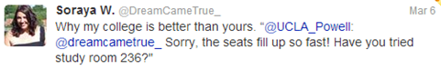
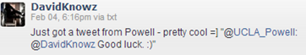

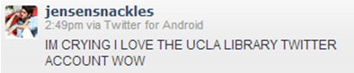

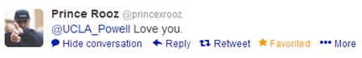
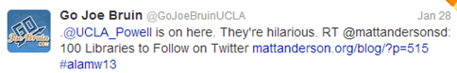
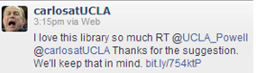

Reference Examples:
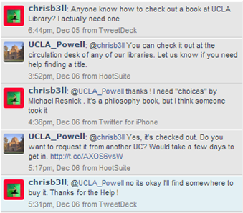

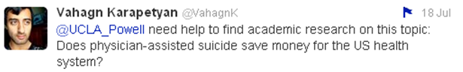

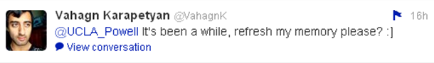



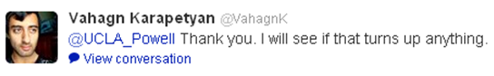

Teaching and Learning Examples:
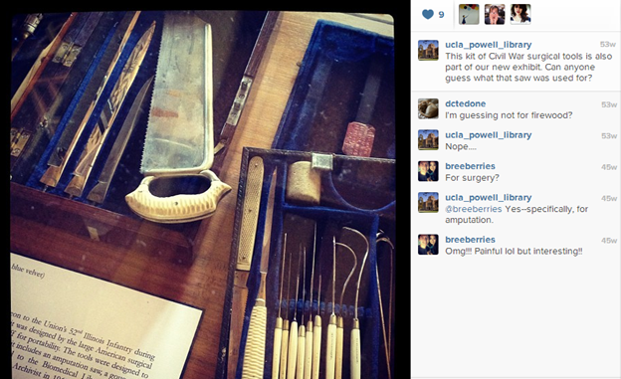

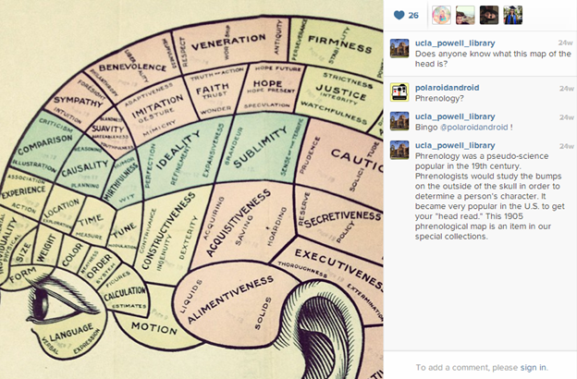

Interns and GSRAs

Interns [Kelly/Doug/Danielle]

Social Media Interns

Three MLIS interns were hired to support our social media efforts. They assisted with the curation, scheduling, and posting of content to all four of our social media accounts. Their internships were rounded out with experiences on the reference desk, in instruction sessions, and doing special projects related to their interests.

All three interns presented their work to the UCLA Library Social Media Learning Group, and two interns presented their work at professional conferences:
- Shannon Lane presented her work on Pinterest in the Emerging Technology Forum at the ARLIS Conference in April
- Michele James presented her work on social media analytics at the Special Libraries Association conference in June

Space Evaluation Interns
Two interns are currently conducting an intensive evaluation of space use modeled on the “direct observation” approach taken in the recent evaluation of the Young Research Library Research Commons.

New directions with TLS Internship program
A new internship description, more directly tied to the evolving mission of Teaching and Learning Services was developed in Spring 2013, resulting in 4 new internship applications for the coming academic year.

This internship meets an ongoing need to provide increased mentoring and experience for UCLA MLIS students in instruction. Experiences will include:
- Assisting with the facilitation of library instruction sessions, training sessions, workshops, and outreach events. Developing lesson plans, activities, and instructional materials.
- Teaching one on one in a variety of contexts, including reference interviews, roving service, digital reference, and consulting with students on the writing and research process.
- Developing online research skills modules.
- Assisting with evaluation of instructional activities.
- Working with Powell Library staff on special projects related to Teaching and Learning Services strategic goals as well as the intern’s skills, interests, and professional goals.

GSRAs [Miki]
College Library began the year with two returning (Stacie Schmidt and Angel Diaz) and one new (Ashley Soo) GSRA. Weekly training sessions were offered to all in concert with GSRAs from CRIS. Angel resigned to take another job on April 21, 2013 to take another job. Stacie will be leaving at the end of the Spring Quarter. In the Spring Quarter, we hired two first year Information Studies students (Joseph Coombe and Nicoletta Beyer) to be trained for next year.

REFERENCE DESK [Miki]
Reference desk staffing was monitored and adjusted during the last year. Summer hours were 10am-6pm, Monday-Thursday and Friday, 10am-5pm. Fall and Winter quarter hours were 9am-7pm, Monday-Thursday, 9am-6pm Friday, 1pm-5pm Saturday and 2pm-6pm on Sunday. The Sunday hours were changed from past years’ 1pm-5pm in order to be more available for our primary clientele. Analysis of Winter statistics led to a change in Spring quarter, when the desk was closed at 6pm.

Examining the statistics collected from public service points raised issues of accuracy and how they reflected the work that was being done. We embarked on a project to better define and normalize the definitions of the statistical categories. This work will continue into the coming year and will be coordinated with the work of the library-wide Evaluation-Value Team, chaired by Doug Worsham.

Teams and Special Projects

Social Media Learning Group [Danielle]
The Social Media Learning Group met twice. Social media interns presented a topic of interest and discussions followed.

Eval>Value [Doug]
The Eval>Value Team, with representatives across the library, seeks to take a stakeholder driven approach to improving UCLA Library’s infrastructure for evaluating and communicating the impact and effectiveness of instructional library activities, with an initial focus on instruction and reference.

The team has collected and organized feedback from staff across the UCLA Library to produce key documents for future efforts, including data maps defining the data collection and reporting needs for instruction, reference, and consultation efforts and short and long term feature requests for current evaluation tools (SIA - Summary of Instructional Activities and Stats - http://stats.library.ucla.edu - the tool used to collect reference statistics), as well as potential vendor tools provided by Springshare.

The team is currently collaborating with DIIT to deliver a set of crucial upgrades and improvements in time for the coming academic year, while at the same developing a long term plan for continual improvement.

OPERATE-UP
The OPERATE-UP action plan - http://j.mp/16VkXlO - outlines priorities for continual improvement of the UCLA Library website and related infrastructure as identified by a sub-team of the OPERATE committee. The sub-team, OPERATE-UP (Unit Priorities) was focused on engaging library staff from units across UCLA Library in conversations about their priorities and perspectives. The rapidly collected an initial set of principles and recommendations based on how units approach web communications as well as the needs of unit level content editors.

These principles and recommendations provide an initial framework for identifying and prioritizing upcoming OPERATE projects and clearly indicate that UCLA Library staff are ready to be engaged in conversations about improving organizational web communications.

First-Year Library Experience Team [Kelly/Doug]
- Discovering Your Library Digital Scavenger Hunt Developed
- Collaboration across library units

Stressbusters [Doug/Bob/Danielle]

- Outstanding feedback from students (quotes)

- Extensive cross-unit collaboration and teamwork

- 24/7 at Powell and YRL: For the first time, the entire College Library was open 24/7 during tenth week and finals. Coffee and fruit was provided to approximately 125 every night around midnight. Study parties were popular and undergraduate expressed appreciation.

- Surprise Pizza Break: On Monday, June 10, of finals week, students were delighted with a surprise pizza break. Twenty five pizzas were served to 190 students at 8 pm.

- Therapy Dogs: In partnership with Ronald Reagan Medical Center’s People Animal Connection, the therapy dog program continued successfully for another year. Staff volunteers assisted PAC teams in serving approximately 150 students each quarter.

- Counseling & Psychological Services (CAPS) partnership

- Silent Disco: In parrtnership with the Center for the Art of Performance College Library hosted undergraduates at two separate Silent Disco events on February 27 (125 attendees), and June 7 (180 attendees).

- Surprize Pizza Study Break:

- YouTube video celebrating student perspective on Stressbusters: http://www.youtube.com/watch?v=cmNRFe31wa0

- Expanded partnership with Office of Residential Life - Academic Development Committee focusing on improved campus awareness of Stressbusters events.

- Piloted use of confluence wiki for project management, cross-unit collaboration, transparent planning, and institutional memory.

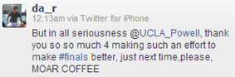
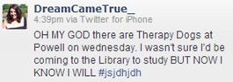
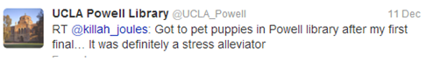
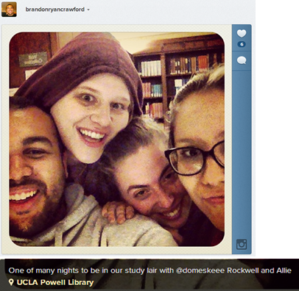
(posted overnight in new 24-hr space)

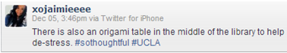
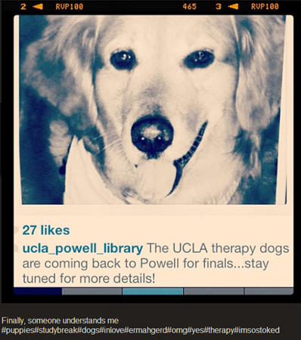

TLS Community Building
Focused on grassroots projects aimed at building infrastructure and collaborative ties across units: Eval > Value, OPERATE, Drupal Users Group, and Online Learning Working Group. Continued efforts to foster a “learning organization” approach to professional development.

Workshop:
Peer Observation and Feedback: 11/6 and 11/28
In this workshop, you’ll learn about the elements of constructive peer observation, from pre-meeting, to observation techniques, to post-teaching debriefing. You’ll also have the opportunity to practice by observing teaching scenarios and discussing approaches and strategies for providing meaningful post-observation feedback.

Brownbags:
Pair Work, Group Work - What works? (2/21)
Librarians as Informationists: New Ways to Support Research (4/26)

User Comment(s):

From Reyna Reyes, transfer student in her 30’s. She is originally from Nicaragua, so English is her second language. She graduated in June 2012 in Sociology. “Alicia, thank you for all your advice. I made it because of you help (sic) me!! Thank you for helping me” - AR (This was written on the back of a graduation picture she brought to me in July 2012)

From Kevin Qian, math/econ major sophomore. He was the UCLA student tour assistance for a group of visitors from Quanzhou Normal University. “Thank you for giving us a great tour, even I learn a lot of thinks (sic) that I never heard before.” -AR

